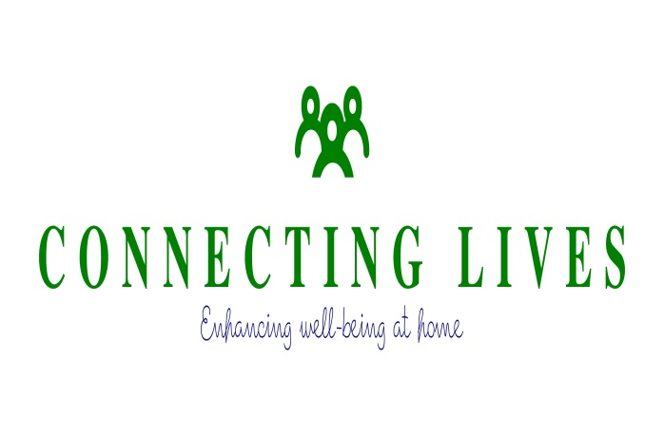
INITIAL REFERRAL FORM
Home-based Support – Adults
Social Isolation, Mental Health
and Wellbeing
THIS IS NOT A HOME CARE SERVICE FOR PERSONAL OR DOMESTIC CARE NEEDS OR A CRISIS SERVICE
If the individual’s needs require urgent attention for these matters please contact the following services:
Health and Social Care – Adults Cornwall: 0300 1234 131
Mental Health Services, Daytime – Adults Cornwall: 0845 207 7711
Out of Hours, Mental Health Services –Adults Cornwall: 0845 230 3902
SUBMIT COMPLETED REFERRALS via email:
leonie@connectinglives.org.in
Please ensure that Referral Forms are Password Protected for Data Protection. The Password can be provided by telephone to Leonie Morris, Director: 07985 755326
Alternatively use initials only and do not include the home address. Again these can be provided by telephone to Leonie Morris, Director :07985 755326
DATE OF REFERRAL |  |  |  |  | / /
Eligibility
☐ The individual is aged 18 or over
☐ The individual is not in Education, Employment or Training or
☐ The individual is retired
☐ The individual is experiencing mild to moderate levels of anxiety or panic disorder, reactive or clinical depression, stress-related symptoms, sleeping difficulties - linked to isolation and loneliness
☐ The individual is not better suited to a referral to Adult Social Care and/or Community Mental Health Services

GP DETAILS
GP Name |  |  |  |  |  |  |  |  | Practice Address
Practice postcode |  |  |  |  |  |  | Practice phone |  |  | Practice fax
GP or practice email
INDIVIDUAL’S DETAILS
First Name |  |  |  |  |  |  |  |  | Last Name
Date of Birth
Marital Status |  | ☐ Never Married ☐ Widowed ☐ Divorced ☐ Separated ☐ Married/Co-habiting
Current Gender Identity |  |  |  | ☐ Male ☐ Female ☐ Trans-Gender ☐ Different Identity …………………….
Address
 |  |  |  |  |  |  |  |  | Postcode
Home Tel: |  |  |  |  |  |  |  |  | Mobile:
Ethnic Origin: |  |  |  |  |  |  |  |  | Religion:
Country of Birth:
Any Physical Disability:
Any Sensory Disability:
Any diagnosis of Dementia type illness:
SOCIAL ISOLATION, LONELINESS AND WELLBEING QUESTIONS
 |  |  |  |  | Referrer to complete as much as possible. Lead Home Assessor for Connecting Lives will revisit with the individual as part of the Initial Home Assessment.
In the last 6 months:
1 | How many days approximately have you participated in meaningful activity outside of your own home? (not including essential activities such as buying groceries) |  |  |  |  |  |  | (Number of Days)
2 | How many days have you felt low in mood, anxious, worried or unable to sleep due to feeling lonely or isolated? |  |  |  |  |  |  | (Number of Days)

3 | How many times have you seen a doctor or any other health professional about these feelings? | (Number of Consultations)
 |  | None of the time | A little of the time |  | Some of the time | Most of the time | All of the time | Not stated / Missing
4 | How often have physical health problems been the main cause of these feelings? | ☐ |  | ☐ | ☐ | ☐ | ☐ | ☐
ADDITIONAL ISSUES
Please indicate if the client has any of the below co-morbid issues
☐ Chronic physical illness, if so please detail…………………………………………………………..

☐ Drug and alcohol issues, if so please detail……. | ☐ Psychosocial stressors such as bereavement, accident, loss of job, divorce/separation, major life event, if so please detail………………………………..
☐ Learning disability, if so please detail…………. | ☐ Feeling Suicidal
☐ Diagnosed mental illness including Personality Disorder, if so please detail…………
Please note that we are not a Mental Health Service. We will not be able to accept referrals for individual’s with a significant history of mental illness or substance misuse difficulties as we are not qualified to meet this level of need but will seek to signpost to other more suitable services. Referrals will be considered on a case by case basis.

Any known risks or hazards at the property including animals? If so please detail……………………………

INDIVIDUAL’S CONSENT: Referral cannot proceed without the individual’s consent
☐ The referrer confirms that the patient understands and consents to the following;
- The individual (and referrer) will be contacted by a member of Connecting Lives to provide confirmation of eligibility for our home-based activities.
- If the individual is not eligible, the decision will be explained clearly and in full and the individual will be signposted to other services. Where necessary the referrer will also be provided with this information.
- If eligible, the individual understands that a member of the Connecting Lives team will be in contact to arrange a home visit.
- Following the home visit it may be necessary for Connecting Lives to speak with other professionals within the support network in order to share information and ensure a co-ordinated approach. This could include the GP. The individual will be asked to sign a Consent Form regarding the sharing of information at the point of the home visit.
REFERRER’S DETAILS (Name, Service/Agency/Relative or Friend, Contact Number and Email Address  Next of Kin/Emergency Contact Details: |  | DATE: | / /

